Introducing live electronic music with Integra Live

Duration: 2 hours

Tutor: Balandino Di Donato, PhD Student

Target audience: Composers, performers and teachers of live electronic music
Keywords: live electronics, interaction, music, technology.

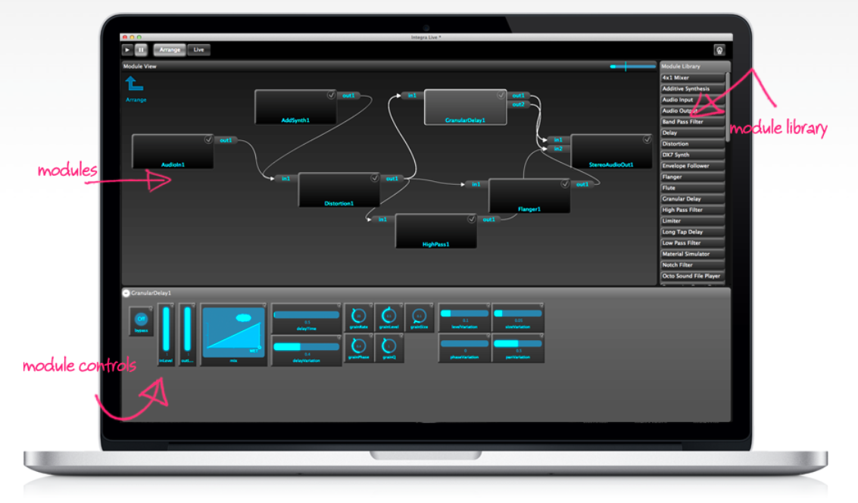

Description

In this workshop we will share with participants the techniques and practice of live electronic music using the Integra Live software (integralive.org). We will introduce the software through a practical “hands on” demo and present a range of live electronic techniques including audio processing and analysis, on screen and tactile control, and automation. We will also describe the activities of the Integra Lab and the Music Technology department at Birmingham Conservatoire and discuss possibilities for future collaboration.
Workshop attendees are invited to bring musical instruments, laptops or work in progress to try with the software.

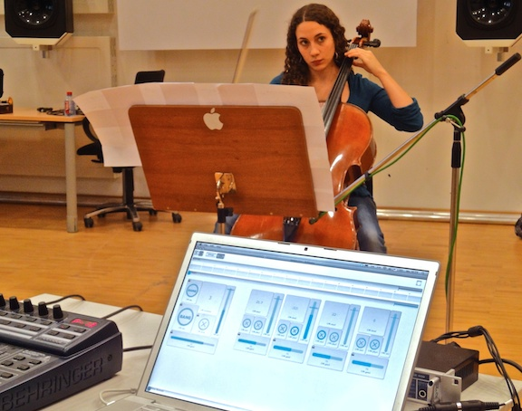

About Integra Lab

Integra Lab (http://integra.io/lab) is an interdisciplinary research lab, with a focus on musician-computer interaction. Our goal is to create new technologies that empower, inspire and delight musicians. Integra Lab provides a unique opportunity for researchers in interactive music technology, user-centred design and digital signal processing to enhance musical experience through direct collaboration with performers and composers.
Integra Lab was founded in 2009 to support the €3.1M EU-funded Integra project. Bringing together new music ensembles, research centres and higher music education institutions from eight European countries and Canada, Integra promoted the wider dissemination of live electronic music and provided composers, performers, teachers and students with the tools to interact with technology in a more user-friendly and musically meaningful way.

Biography

Balandino Di Donato is PhD Student in Music technology at Birmingham Conservatoire. He started his musical studies at A. Casella Conservatoire of L’Aquila (Italy), where he achieved his bachelor degree with a thesis regarding the usage and the development of application for the Tangible User Interface "Metis". In 2013, Balandino has worked at the IntegraLab, where he covered the role of Module Developer and Debugger. In addition, he has been working for CRM - Centro Ricerche Musicali di Roma, national and international concerts and tours as a sound engineer and artistic assistant.

Website: http://balandinodidonato.com
Twitter: @balandino_dd

